Lab 3

Isaiah Hoffer

LAB Q 1

LAB Q 2

LAB Q 3

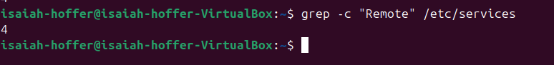

LAB Q 4

LAB Q 5

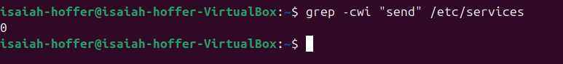

LAB Q 6

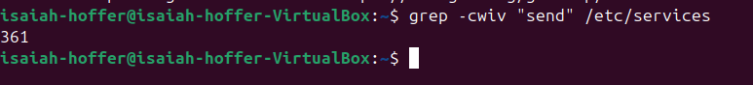LAB Q 7

For Q 7 I did decide to show the output for files lines without the word ‘send’ because for some reason I don’t seem to have files with it, not sure if I’m supposed to.

LAB Q 8

LAB Q 9

